Chapter 18, Problem 15.

Find the Fourier transforms of the following functions:

- f(t) = δ (t + 3) - δ (t - 3)
- 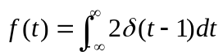
- f(t) = δ (3t) - δ'(2t)

